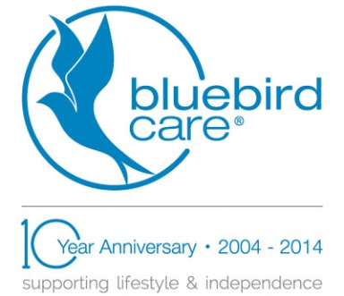
Press Release
July 1, 2015
Burnham-based Bluebird Care scoops Achiever Award for outstanding staff training
Burnham-based care at home provider Bluebird Care has won an employer Achiever Award from Bracknell and Wokingham College after 11 of their carers completed BTECs in Dementia Care at the college.
The award, usually reserved for individual students, was given to Bluebird Care, of Summers Road, in special recognition of their commitment to staff training. The company, which provides homecare across the Slough, South Berkshire and South Wycombe areas, took part in the college’s Skills for the Workforce programme, a Government-funded project which allows Berkshire-based companies to access free, accredited training for staff aged over 19.
College principal, Campbell Christie, CBE said: “Companies who take part in this project show a real commitment to developing their staff and providing them with the opportunity to complete industry-recognised qualifications. In the past 12 months Bluebird Care has truly shown this commitment by using funding from this project to send 11 of their carers to the college.
“Ultimately, the European Social Funding (ESF) and the college’s training have been critical in enabling Bluebird Care to offer their staff a much better understanding of the needs of the people they care for, allowing their customers to stay safe in their own homes, whilst having a positive impact on their lives each and every day.”
Bluebird Care received the accolade at the college’s Achiever Awards Evening on June 29, which also featured guest speaker Olympic gold rowing medallist Lt. Peter Reed MBE.
Bluebird Care deputy care manager Katy Cresswell, who worked closely with the college said: “With the terrific support of course tutors Cheryl Spence, Joy Baker and their team, 11 carers have successfully achieved their BTEC in Dementia Awareness. While being something that the care staff can be proud of, it is also fundamental to ensuring that our staff are highly trained, capable and confident when working with vulnerable adults in the community.
“ESF Funding gives Bluebird Care staff a recognised qualification in health and social care and also the confidence to go on to do the full award in health and social care.”
Course tutor Cheryl Spence said: “Bluebird Care is doing its best to raise the profile of a career in care, and to make it aspirational for those who may not have previously considered the health and social care sector.”
Award-winning Bluebird Care, which employs over 100 carers locally, provides a variety of care in people’s own homes, from short visits to live-in support. It is currently recruiting more carers. Get in touch on 01628 605797.
…ends…

Media enquiries: to arrange interviews with Katy Cresswell or Bluebird Care director Ian Inglis, please contact Cathy Kelly at ckellypr@gmail.com or on 07704 130226.

