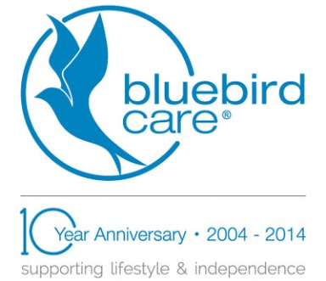
Press Release
August 24, 2015
Bluebird Care creates 15 jobs and plans for further expansion as demand increases
Burnham-based Bluebird Care has recruited 15 additional members of staff over the past two months and is planning further jobs as demand for its homecare services continues to grow.
Since June, it has strengthened its Summers Road office and management team with Elaine Phillpot joining as Recruitment Manager, Kellie Murray appointed as Office Administrator and Annie Greenfield joining to assist with Speech & Language Therapy for their clients. It has also recruited an additional 12 carers – swelling its total number of staff to over 100.
Kellie has worked in an office environment for the past eight years carrying out a variety of roles from PA to payroll and administrator roles, whilst Annie joined straight from University where she graduated with a BSc in Biology.
Elaine previously worked as a carer achieving her NVQ 2 in 2009, subsequently taking on an HR role with the Reading office of Bluebird Care before assuming similar responsibilities for the Burnham based office.
There have also been a number of internal promotions, including Libby Irvine and Lorna Thomas both to Care Supervisor whilst Lisa Buckland has joined the management team.
The award-winning homecare provider is planning further appointments for a number of additional senior carer and field supervisor positions to support those already in place.
Director Ian Inglis said “It’s been an amazing year and we continue to grow and expand as the demand for our services increases. People want to stay independent in their own homes for as long as possible and we pride ourselves on delivering an outstanding level of care.
“We have restructured internally to enable us to meet the challenges of growth as well as taking on additional staff. The new members of the team have settled in well and we are already feeling the benefit of having them on board.”
Award-winning Bluebird Care provides a variety of care in people’s own homes across the Slough, South Buckinghamshire and South Wycombe areas, from short visits to live-in support.
Last month (July), it won an employer Achiever Award from Bracknell and Wokingham College after 11 of their carers completed BTECs in Dementia Care at the college.

ends

Media enquiries: to arrange interviews with Ian Inglis, please contact Cathy Kelly at ckellypr@gmail.com or on 07704 130226.

